
DAWLADA GOBOLEEDKA WAQOOYI-BARI SOMALIYA
WASAARADDA QORSHAYNTA
HORUMARINTA IYO XIDHIIDHKA
CAALAMIGA AH

NORTHEASTERN STATE OF SOMALIA
MINISTRY OF PLANNING,
DEVELOPMENT AND INTERNATIONAL
COORDINATION

NORTHEASTERN STATE OF SOMALIA (WOQOOYI BARI)
CONSUMER PRICE INDEX (CPI) REPORT.
Reporting: Ministry of Planning, Development and International Cooperation (MoPDIC)
Department: Statistics Department
Indicator: All Items Consumer Price Index (CPI)
Geographical Coverage: Las Anod, Buuhoodle, Taleh, and Erigavo
Reference Period: 2026
Prepared by: Statistics Department
1. Executive Summary
This report presents a comparative analysis of the All-Items Consumer Price Index (CPI) across four locations in Northeastern State of Somalia: Las Anod, Buuhoodle, Taleh, and Erigavo. The analysis focuses on differences in the reported CPI index levels and their implications for understanding household living costs and local economic conditions.
The reported CPI values show considerable variation across the four locations. Las Anod recorded the highest index at 118.7, followed by Buuhoodle at 111.6, Taleh at 109.9, and Erigavo at 96.3.
The difference between the highest and lowest reported index values is 22.4 index points. Las Anod's index is approximately 23.3% higher than Erigavo's index, indicating a substantial difference in the measured index levels between the two locations.
These findings provide a useful basis for further investigation of geographical differences in consumer prices. However, the figures alone do not establish the causes of these differences or demonstrate which location experienced the highest inflation during a particular period.
2. Comparative CPI Results
Rank | Location | All Items CPI | Share of Sum of Four Indices
1 | Las Anod | 118.7 | 27.6%
2 | Buuhoodle | 111.6 | 25.9%
3 | Taleh | 109.9 | 25.5%
4 | Erigavo | 96.3 | 22.4%
 | Total | 436.5 | 100.0%
Note: The percentage column represents each location's share of the sum of the four reported index values. It is not a measure of inflation, household expenditure, or the proportion of the population affected by price increases.
3. Detailed Analytical Findings
3.1 Las Anod: Highest Reported CPI Index
Las Anod recorded the highest All Items CPI index at 118.7. This places it 7.1 index points above Buuhoodle and 22.4 points above Erigavo.
The result indicates that Las Anod has the highest reported index level among the four locations under the measurement represented by these figures. This finding warrants closer examination of prices for essential food items, housing, transport, utilities, and other household consumption categories.
Potential explanations for differences in market prices could include transportation costs, supply-chain conditions, market demand, availability of goods, and local market structures. However, additional price and market data are required to determine whether these factors explain the observed difference.
3.2 Buuhoodle: Second-Highest Index
Buuhoodle recorded a CPI index of 111.6, ranking second among the four locations. Its index is 7.1 points below Las Anod and 15.3 points above Erigavo.
This position indicates that Buuhoodle's reported index level is relatively close to Taleh's, with a difference of only 1.7 points. Continued price monitoring would help establish whether this relationship remains stable across reporting periods or changes as market conditions evolve.
3.3 Taleh: Intermediate Index Level
Taleh recorded an index of 109.9, placing it third in the comparison. The difference between Taleh and Buuhoodle is relatively small, at 1.7 index points, while the difference between Taleh and Erigavo is 13.6 points.
This suggests that Taleh occupies an intermediate position within the current comparison. Monthly analysis would be useful for identifying changes in the relative positions of the four locations and determining whether price movements are concentrated in particular commodity groups.
3.4 Erigavo: Lowest Reported CPI Index
Erigavo recorded the lowest index value at 96.3. Its index is 22.4 points below Las Anod, 15.3 points below Buuhoodle, and 13.6 points below Taleh.
This indicates a lower reported CPI index level relative to the other locations. It should not automatically be interpreted as proof that Erigavo has the lowest absolute cost of living or that prices there have declined. Such conclusions depend on the CPI base period, index construction, consumption weights, and changes over time.
4. Quantitative Comparison
The following table summarizes the index-point differences between locations.
Comparison | Difference in Index Points
Las Anod – Buuhoodle | 7.1
Las Anod – Taleh | 8.8
Las Anod – Erigavo | 22.4
Buuhoodle – Taleh | 1.7
Buuhoodle – Erigavo | 15.3
Taleh – Erigavo | 13.6
The largest difference is between Las Anod and Erigavo, while the smallest is between Buuhoodle and Taleh. This suggests that the most pronounced variation in the reported index levels occurs between Las Anod and Erigavo.

Where prices moved, by category
Food fell 7.3% in Ceerigaabo but rose 19.1% in Las Anod; non-food goods drove Buuhoodle's rise. Index shown for September (May = 100), equal-weighted within each COICOP division; items per division are in brackets.
COICOP division | Ceerigaabo | Taleex | Las Anod | Buuhoodle
01 Food & non-alcoholic beverages | 92.7 (58) | 108.2 (65) | 119.1 (68) | 111.8 (65)
03 Clothing & footwear | 91.4 (80) | 111.7 (83) | 119.1 (76) | 87.8 (82)
04 Housing, water & energy | 101.9 (21) | 111.3 (21) | 119.9 (20) | 94.3 (20)
05 Furnishings & household goods | 100.1 (69) | 108.1 (68) | 122.1 (63) | 107.8 (60)
06 Health | 101.9 (17) | 104.6 (17) | 133.9 (17) | 105.2 (17)
07 Transport | 102.2 (20) | 120.0 (19) | 123.0 (19) | 108.4 (19)
10 Education | 100.0 (5) | 104.1 (5) | 100.0 (5) | 100.0 (5)
All items | 96.3 | 109.9 | 118.7 | 111.6
Las Anod's health index (105.4) comes mostly from medicines recorded at half their May price (for example 1.00 to 1.3 USD); verify these before relying on it. Alcohol and tobacco (division 02) is left out: only Taleex has a price (cigarettes), recorded from July.

Staple food prices
Cooking oil fell in Ceerigaabo (1.75 to 1.00 USD per litre) and fresh cow milk rose in all four towns (+15% in Taleex to +90% in Ceerigaabo). Prices in USD, May and September.
Item (unit) | Ceerigaabo | Taleex | Buuhoodle | Las Anod
Sugar white (1 kg) | 0.55 → 0.75 | 0.65 → 1.00 | 0.6 → 0.9 | 0.64 → 1.1
Rice, imported (1 kg) | 0.4→ 0.52 | 0.55 → 0.88 | 0.45 → 0.60 | 0.52 → 0.73
Wheat grain (750 g tin) | 0.75 → 1.00 | 0.75 → 0.72 | 0.75 → 0.55 | 0.75 → 1.20
Sorghum (750 g tin) | 0.60 → 0.50 | 0.60 → 0.57 | 0.60 → 1.20 | 0.60 → 0.70
Maize (750 g tin) | 0.50 → 1.00 | 0.50 → 0.55 | 0.50 → 0.70 | 0.50 → 0.90
Cooking oil (1 litre) | 1.75 → 1.00 | 1.75 → 1.67 | 1.75 → 1.70 | 1.75 → 1.80
Cow milk, fresh (1 litre) | 1.00 → 1.90 | 1.00 → 1.15 | 1.00 → 1.40 | 1.00 → 1.55
Camel milk, fresh (1 litre) | 1.25 → 1.00 | 1.25 → 1.58 | 1.25 → 1.40 | 1.25 → 1.55
Eggs (1 piece) | 0.25 → 0.30 | 0.25 → 0.35 | 0.25 → 0.30 | 0.25 → 0.30
Black tea, bulk (1 kg) | 2.00 → 2.00 | 2.00 → 2.60 | 2.00 → 2.30 | 2.00 → 2.40
Every town starts from the same May price for each item, which is the baseline problem explained below.

Food price index by town
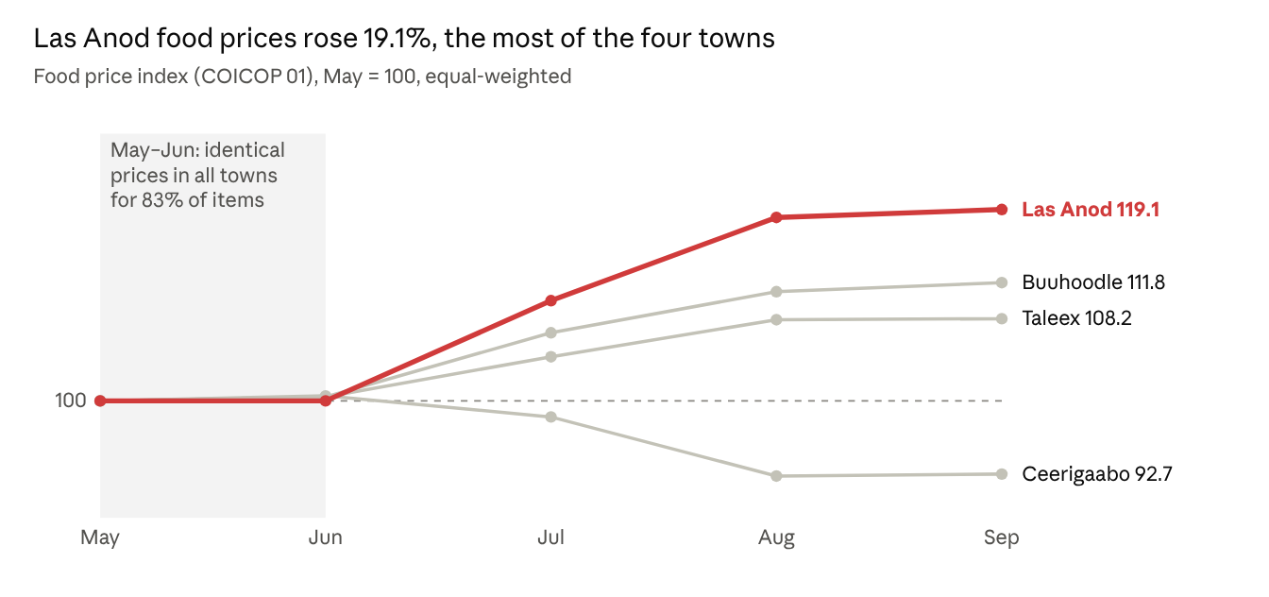
Northeastern CPI sheets for Ceerigaabo, Taleex, Buuhoodle and Las Anod · May–Sept 2026 · Jevons index, May = 100
Las Anod has the highest food inflation of the four towns (+19.1% since May), although its all-items index is flat (99.6) because clothing, health and housing prices fell. The four-town all-items average rose from 100 to 106.1. Most of the movement came after June: the average gained 3.5% in July and 2.2% in August, then 0.3% in September.
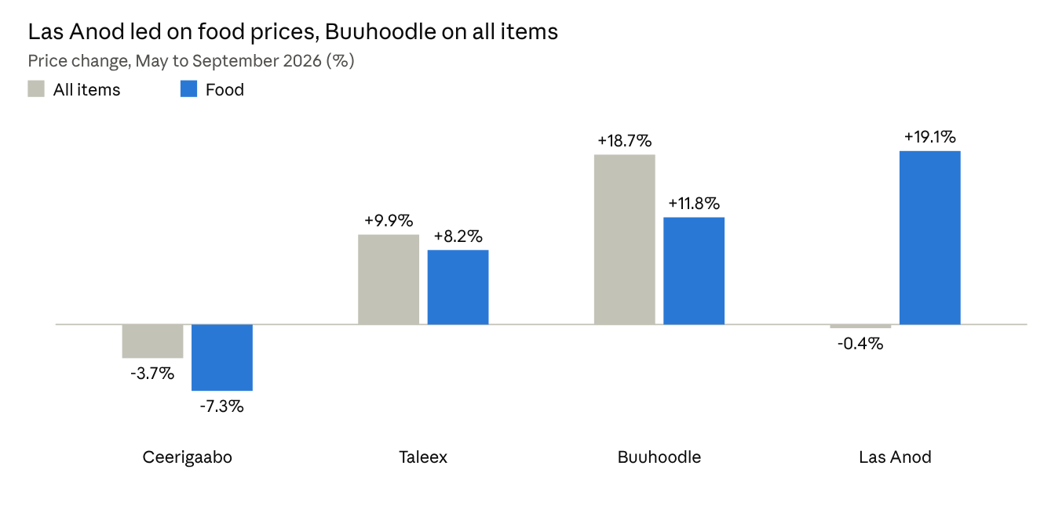
Northern Eastern state CPI sheets, four towns · May Sept 2026 · Jevons index change, large jumps excluded
Food and all-items prices diverge most in Las Anod (+19.1% against −0.4%) and Buuhoodle (+11.8% against +18.7%), so read both measures together.
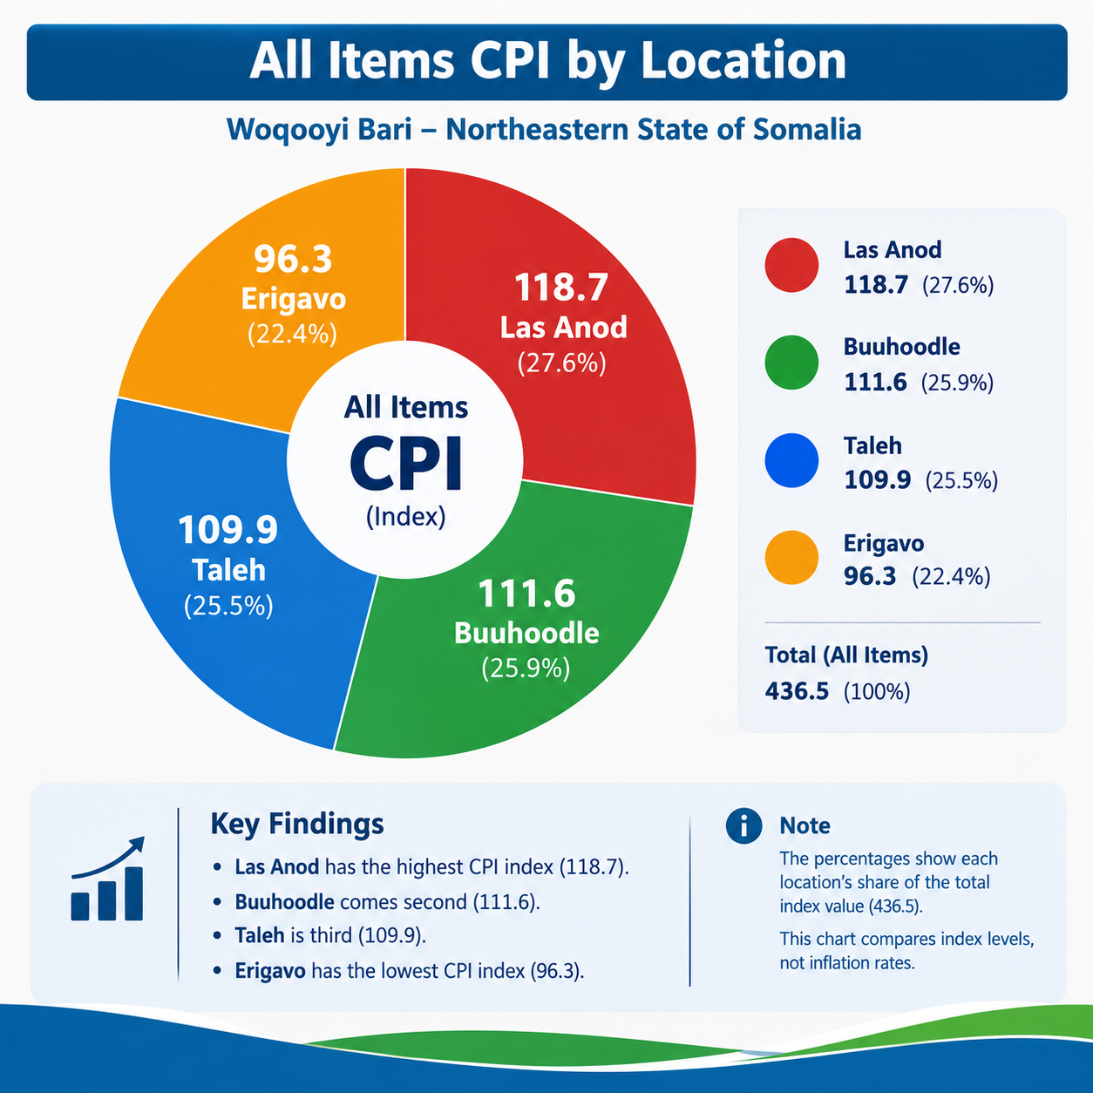
Figure 1: All Items Consumer Price Index (CPI) by Location in Woqooyi Bari
Figure 1 illustrates the distribution of the All Items Consumer Price Index across four locations in Woqooyi Bari. Las Anod recorded the highest CPI index at 118.7, followed by Buuhoodle at 111.6 and Taleh at 109.9, while Erigavo recorded the lowest index at 96.3. The difference between the highest and lowest values was 22.4 index points, indicating variation in the reported CPI levels across the locations. Overall, the figure highlights geographical differences in the CPI index, although further analysis of comparable data over time is required to establish inflation trends.

Interpreting the Price Data
The May–September price series contains substantial data-quality concerns, particularly in the May and June observations. The unusually high level of identical prices across locations and the persistence of unchanged values between May and July suggest that the early observations may have been carried forward from a common template rather than independently recorded market prices. Consequently, the July–September period provides a more informative basis for preliminary analysis of price movements, although it also requires validation.
Identical May and June prices. Approximately 83% of the items had identical reported prices across all four locations in May and June. From July onward, only around 1–2% of items showed this pattern. Furthermore, approximately 99% of item prices remained unchanged between the third week of May and the first week of July. These patterns raise concerns about the independence and reliability of the earlier observations.
July–September price movements. When July is rebased to 100, the September indices are 98.1 for Ceerigaabo, 104.7 for Taleex, 107.4 for Buuhoodle, and 111.3 for Las Anod. These preliminary results indicate a decline in the measured price index for Ceerigaabo and increases in the other three locations. For food items alone, the corresponding indices are 94.2, 103.6, 104.7, and 108.2, respectively.
These figures represent changes in the constructed indices, not official inflation rates. Their interpretation depends on the validity and comparability of the underlying observations.
Changes in Ceerigaabo's market coverage. The price observations for Ceerigaabo were collected from Shacabka Market in May and June, while Daalo Market was used from July onward. This change in market coverage introduces a comparability problem. Therefore, the observed decline may partly reflect differences between the two markets rather than changes in prices over time. The July–September trend should also be interpreted cautiously until market coverage is standardized.
Extreme price changes and potential recording errors. A total of 52 out of 1,150 town–item price series recorded movements exceeding a factor of two: Taleex (7), Ceerigaabo (13), Buuhoodle (16), and Las Anod (16). Examples include olive oil in Taleex declining from USD 7.00 to USD 0.80 per litre and private car prices falling from USD 4,000 to USD 400. Such changes may reflect unit inconsistencies, transcription errors, differences in product specifications, or genuine market changes. They should be investigated individually before exclusion.
The sensitivity analysis indicates that including these observations changes the town indices by as much as four index points. The resulting alternative values are 94.2 for Ceerigaabo, 105.6 for Taleex, 121.4 for Buuhoodle, and 100.5 for Las Anod. These results demonstrate that a relatively small number of extreme observations can materially influence the estimates.
Round-number price movements. Several low-priced items exhibit exact percentage changes, such as an increase from USD 1.00 to USD 2.00 or a decrease by half. These patterns may reflect genuine price changes, rounding practices, or data-entry decisions. Additional verification is necessary before attributing them to actual market inflation.
Missing observations and collection gaps. May contains one observation per item, recorded in the third week. From July onward, some locations contain duplicate observations for the same week. Zero prices reported for items such as herbal medicine are treated as missing, and 14 items lack observations in at least one month. These gaps may affect the consistency and reliability of the resulting indices.
2. The Main Causes of Inflation
Inflation refers to a sustained increase in the general price level of goods and services over time. It is commonly explained through three mechanisms.
2.1 Demand-Pull Inflation
Demand-pull inflation occurs when demand for goods and services increases faster than available supply, placing upward pressure on prices.
Example: A drought may reduce the availability of camel milk. If household demand remains high while supply declines, sellers may increase prices because consumers are competing for a limited quantity of milk.
2.2 Cost-Push Inflation
Cost-push inflation occurs when the costs of production, transportation, or distribution increase, leading businesses to raise retail prices.
Example: If fuel prices rise, transporting rice from ports and wholesale markets to inland locations such as Taleex becomes more expensive. Traders may pass some of these additional costs on to consumers through higher retail prices.
2.3 Built-In Inflation
Built-in inflation refers to the interaction between rising prices, wage demands, and business costs. When the cost-of-living increases, workers may seek higher wages. If businesses respond by increasing the prices of their goods and services, further price pressures may develop.
This mechanism is sometimes described as a wage–price spiral. However, its presence in Woqooyi Bari cannot be established from the current price dataset alone; wage and production-cost information would also be required.
3. Why Price Movements May Differ Across Locations
Inflation and consumer price movements can vary geographically because local markets differ in supply conditions, transportation networks, demand patterns, and access to goods.
Transportation Costs and Market Accessibility
Locations that depend heavily on goods transported over long distances may face higher distribution costs. Fuel prices, road conditions, transport availability, and the distance between suppliers and retail markets can all affect final consumer prices.
For Taleex, transportation costs are a plausible factor to investigate when explaining differences in retail prices. However, the available CPI observations do not independently establish that distance or transport costs caused the reported price movements. Transport-cost data and information on supply routes would be needed to test this explanation.
Local Supply and Commodity Availability
Differences in local production and access to supplies can influence the prices of individual commodities. For example, the reported charcoal price of USD 12.00 in Buuhoodle, compared with USD 15.00 in Ceerigaabo, suggests a difference in the observed prices of this commodity.
Possible explanations include differences in supply, sourcing, transport costs, product quality, or market conditions. The price comparison alone does not establish that Buuhoodle has a more abundant local supply or lower fuel inflation.
Seasonal and Short-Term Market Fluctuations
Prices for perishable and livestock-related products, including fresh camel milk, may fluctuate with seasonal supply, weather conditions, livestock productivity, and daily market availability.
The reported movement in camel milk prices between USD 1.00 and USD 2.00 illustrates the importance of monitoring volatile commodities. Nevertheless, these observations should be verified to determine whether the changes reflect genuine market movements, differences in measurement, or recording inconsistencies.
Methodology
The preliminary index is calculated using an unweighted geometric mean of price relatives, commonly referred to as the Jevons index. Item price relatives are calculated against the May reference period, using items with reported prices in all five months from May through September. Where multiple observations exist within a month, the observations are averaged according to the applied calculation procedure.
The available spreadsheets contain no populated expenditure-weight columns. Consequently, the index assigns equal importance to each included item rather than reflecting the relative share of household expenditure devoted to different goods and services.
This approach differs from a weighted CPI, in which expenditure weights reflect household consumption patterns. Under an unweighted method, clothing, household goods, food, and other items may influence the index in ways that do not correspond to their actual importance in household budgets.
The four-location comparison is based on a simple arithmetic average of the individual location indices rather than a population-weighted or expenditure-weighted state-level index. All reported prices are denominated in United States dollars (USD).
Important methodological clarification: The July = 100 indices reported above are separate from indices rebased to May = 100. The reference period must be stated consistently in every table and figure. The method used to calculate the July–September series should also be documented clearly, including the treatment of missing values, duplicate observations, and extreme price changes.
The resulting estimates should be described as preliminary analytical indices rather than official SNBS CPI statistics unless they have been calculated and validated in accordance with the applicable official methodology.
Recommendations for Improving CPI Data Quality
- Verify May and June observations. Review original field records and electronic submissions to establish whether identical prices were independently observed or carried forward from earlier records.
- Standardize market coverage. Collect prices from consistent markets in each location or document and adjust for changes in market coverage where methodologically justified.
- Investigate extreme price movements. Check units of measurement, product specifications, currency entries, and original observations before excluding unusual values.
- Strengthen data validation. Introduce automated checks for duplicate records, unchanged prices, zero values, missing observations, and unusually large month-to-month changes.
- Improve collection consistency. Ensure that field teams follow standardized procedures for recording prices, dates, units, product quality, and market identifiers.
- Develop expenditure weights. Where suitable household expenditure data are available, apply an appropriate weighted CPI methodology consistent with recognized statistical standards.
- Publish transparent methodological notes. Clearly document reference periods, index formulas, exclusions, missing-data treatment, and limitations in all published reports.
Conclusion
The May–September 2026 CPI dataset for Ceerigaabo, Taleex, Buuhoodle, and Las Anod provides an initial basis for examining geographical price movements in Woqooyi Bari. However, identical early-period prices, changes in market coverage, extreme observations, and missing data raise important concerns about comparability and reliability.
The July–September results provide a useful preliminary indication of price movements, with the constructed indices increasing in Taleex, Buuhoodle, and Las Anod while declining in Ceerigaabo. These findings should not be interpreted as definitive inflation estimates until the underlying data have been verified and the methodological limitations addressed.

Reference:
Las Anod Market CPI Dataset (May–September 2026).
Taleex Market CPI Dataset (May–September 2026).
Buuhoodle Market CPI Dataset (May–September 2026).
Ceerigaabo Market CPI Dataset (May–September 2026).
Source: Statistics Department, Ministry of Planning, Development and International Cooperation (MoPDIC), Northeastern State of Somalia (Woqooyi Bari).

Signature_____________________________
Director of statistics department
Hassan Hashi Aden

